PROJECT DESIGN PHASE-II

**TECHNOLOGY ARCHITECTURE**

|  |  |
| --- | --- |
| **Date** | 03 October 2022 |
| **Team ID** | PNT2022TMID10584 |
| **Project Name** | AI-powered Nutrition Analyzer for Fitness Enthusiasts |
| **Maximum Marks** | 4 Marks |

Technical Architecture:

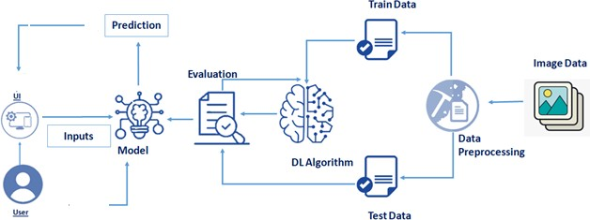

Table-1 : Components & Technologies:

|  |  |  |  |
| --- | --- | --- | --- |
| **S.No** | **Component** | **Description** | **Technology** |
| 1. | **User Interface** | How user interacts with application e.g., Web UI, Mobile App, Chatbot etc.  Web UI | HTML, CSS, JavaScript |
| 2. | **Database** | Data Type, Configurations and data will be stored. | MySQL, Js etc. |
| 3. | **Cloud Database** | Database Service on Cloud | IBM DB2, IBM Cloud ant etc. |
| 4. | **File Storage** | File storage requirements | IBM Block Storage or Other Storage  Service or Local Filesystem |
| 5. | **Machine Learning Model** | Purpose of Machine Learning Model  CNN model for identification and classification of data from users. | ANN, CNN, RNN  Object Recognition and image classification Model, suggestion and recommendation. [CNN, Open CV] |

Table-2: Application Characteristics:

|  |  |  |  |
| --- | --- | --- | --- |
| **S.No** | **Characteristics** | **Description** | **Technology** |
| 1. | **Open-Source Frameworks** | Flask  List the open-source frameworks used | Technology of Opensource framework  NEXT, DJANGO, TENSORFLOW, OPENCV |
| 2. | **Security Implementations** | Data protection  List all the security / access controls implemented, use of firewalls etc. | Authorized APIs Only  SHA-256, Encryptions, IAM Controls,  OWASP etc. Django’s default security management |
| 3. | **Scalable Architecture** | Micro-services  Scalability of architecture (3 – tier, Micro-services) | Micro web application by Flask  IBM Cloud |

|  |  |  |  |
| --- | --- | --- | --- |
| **S.No** | **Characteristics** | **Description** | **Technology** |
| 4. | **Availability** | Distributed servers  Justify the availability of applications (e.g., use of load balancers, distributed servers etc.) | Android IBM Cloud |
| 5. | **Performance** | High Flexibility, Quick accessibility  Design consideration for the performance of the application (number of requests per sec, use of Cache,  use of CDN’s) etc. | Framework IBM Cloud |